Educator and Student Scholarships
For CANDLES Kansas City 2021 Trip

CANDLES Holocaust Museum and Education Center is pleased to announce the availability of Educator and Student Scholarships for the upcoming Kansas City 2021 trip with the generous support of the Florence and Laurence Spungen Family Foundation.
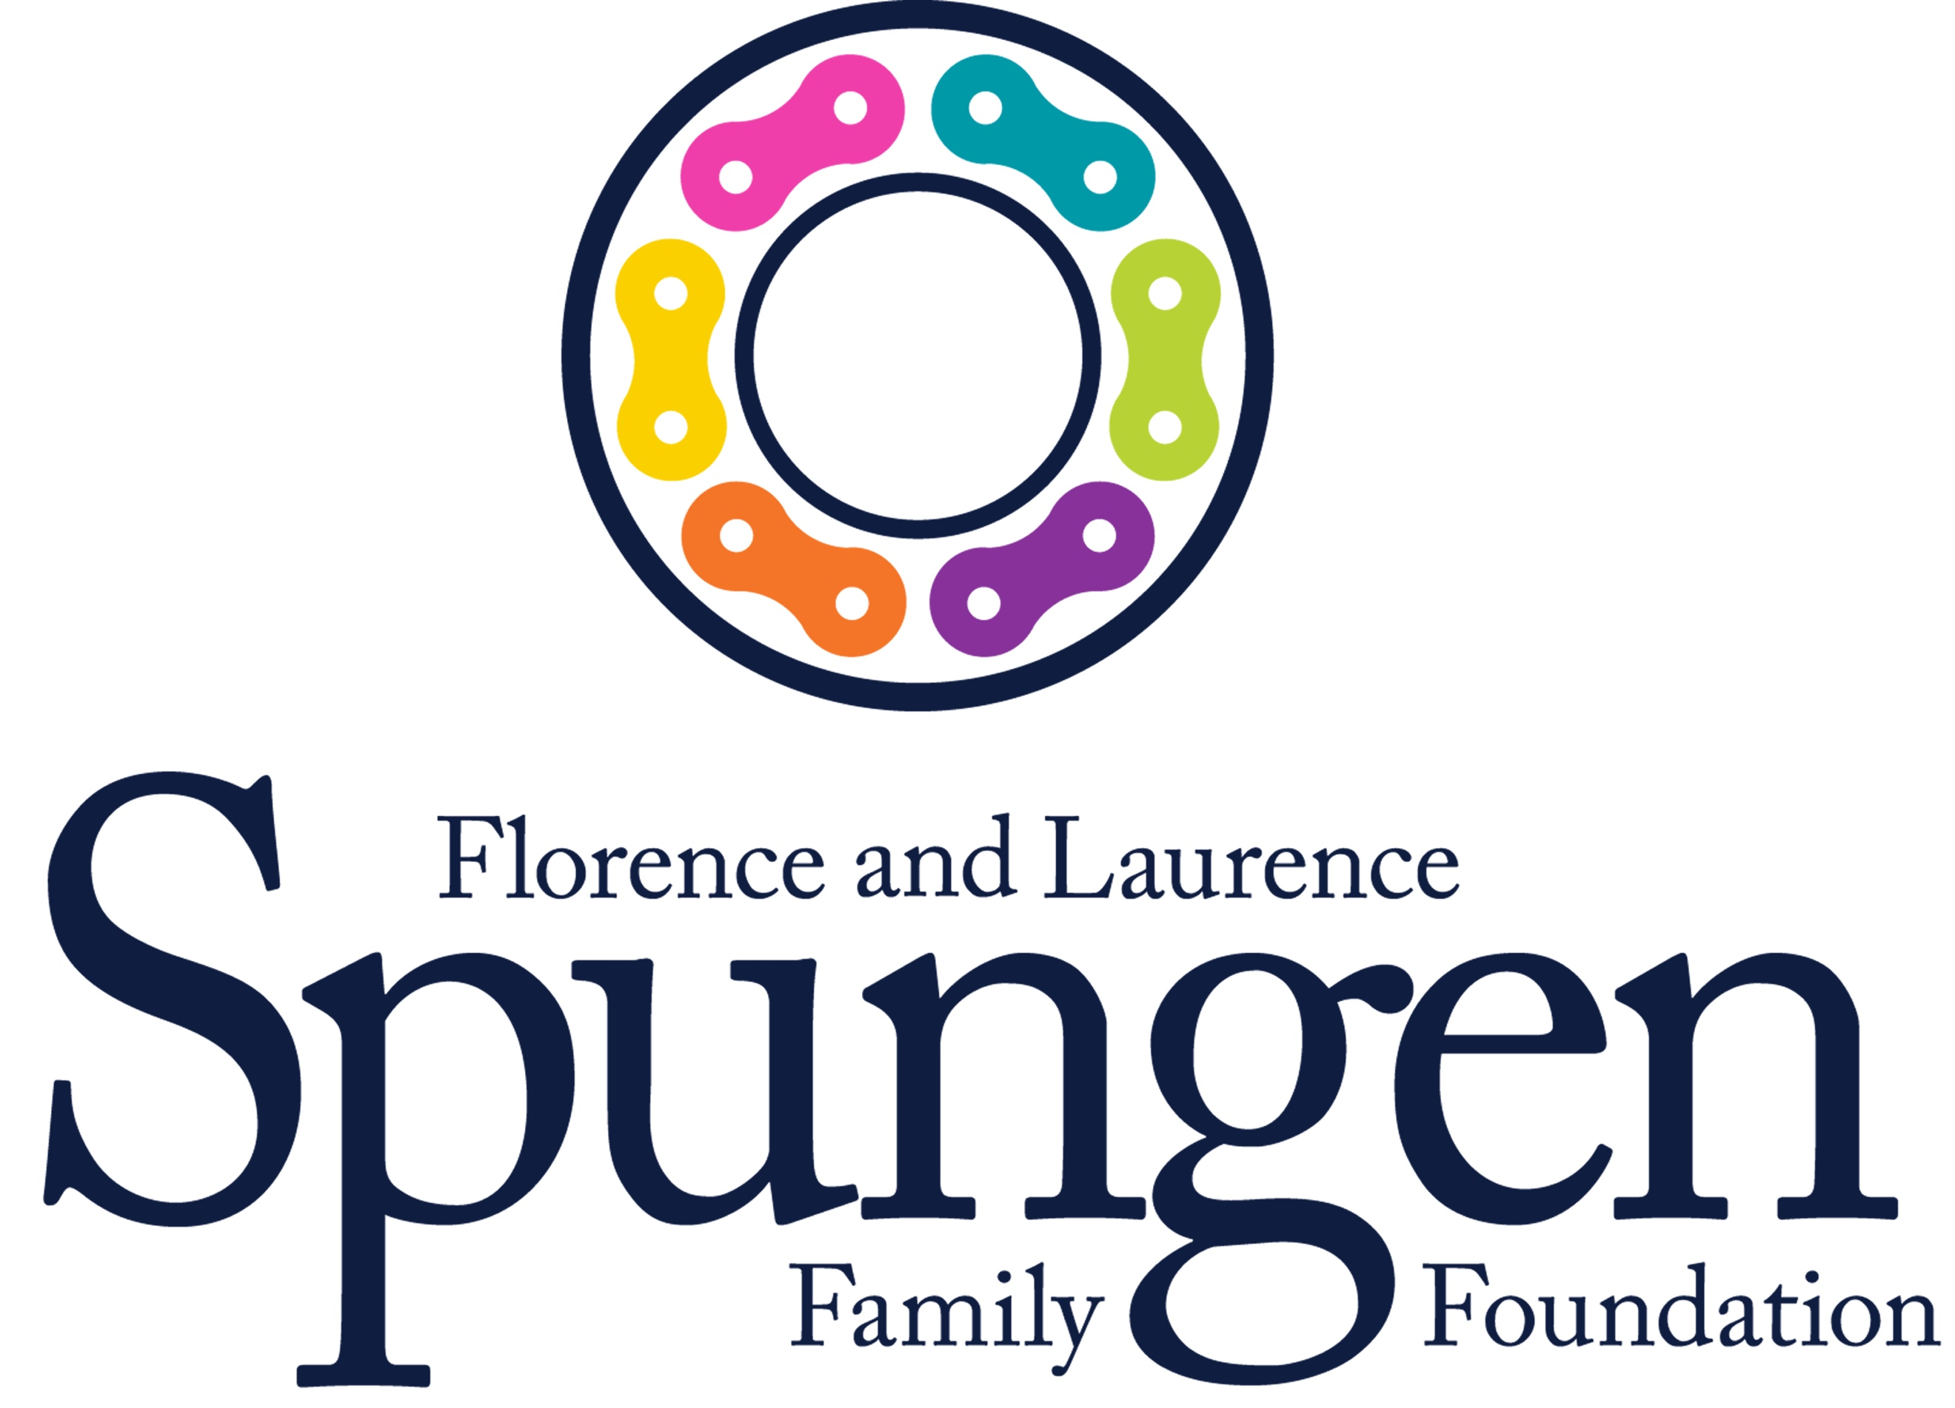
These scholarships will be available for high school and college students as well as for teachers and professors. “The mission of the Florence and Laurence Spungen Family Foundation is to improve the quality of life of individuals and families facing health challenges, and to address issues that particularly affect the Jewish community. The Foundation supports building awareness about the importance of genetic screening to fight cancer, supporting family caregivers, and facilitating discussions about the Holocaust and genocide.” Additionally, the Spungen Foundation has created one of the largest and most extensive privately owned Holocaust collections in the world.

Kansas City 2021

The CANDLES Auschwitz trip offers individuals the valuable learning opportunity of experiencing Auschwitz through a world-renowned collection of over 700 artifacts curated into the exhibit “Auschwitz. Not long ago. Not far away.” Participants will also learn about WWI through visiting the National World War I Memorial and Museum and gain an understanding of the historical events which led up to the Holocaust and WWII. This experience will allow participants to learn not only about Eva Kor’s story and her connection to Auschwitz but also about Walter Sommers and his story as a Holocaust survivor and WWII veteran.

This scholarship is open to both educators and students. For this scholarship educators will be defined as individuals who have worked as licensed teachers including guidance counselors and library/media specialists, principals and assistant principals, and school resource officers in public and private school, and professors at accredited universities. Students who are currently enrolled in either high school or in a university for any type of degree are also eligible to apply for this scholarship. Additionally, any individual who works with youth or adults in a setting where teaching Holocaust education can change a life is eligible. CANDLES offers this support as a way to encourage personal and professional growth, as well as contribute to overall student and public understanding of the value of learning lessons of the Holocaust to create kinder and more equitable communities for all people.

CANDLES will award $500 scholarships. Application materials will be judged on clarity, substance, and overall appeal. Preference will be given to those that propose meaningful and creative ways to educate students and/or the general public and demonstrate an understanding of the relevance of Holocaust education. Proposals that integrate multiple subjects/disciplines are encouraged.

APPLICATION REQUIREMENTS

PLEASE SUBMIT ONE COMPLETE COPY OF ALL YOUR MATERIALS.
There is no specific application format. However, you should prepare your materials using a font size of 11 or 12 points. Answers to items 2-6 should not exceed three single-spaced pages total. Your description should convince the committee of your commitment to use this experience to educate others and promote CANDLES Holocaust Museum and Education Center as a resource for Holocaust education.

1) PERSONAL INFORMATION
Use the provided form to submit your personal information. If more space is needed, you may recreate this form to accommodate the length of your information. All parts must be completed; if not possible, please provide an explanation.

2) BRIEFLY DESCRIBE YOUR LEVEL OF KNOWLEDGE ABOUT THE HOLOCAUST AND HOLOCAUST EDUCATION

3) WHY IS YOUR PARTICIPATION IMPORTANT FOR YOUR PERSONAL GOALS?

4) EDUCATION
Please explain how you will use this experience in a classroom, workshop, or informal setting. How will you educate others?

5) HOW WILL YOUR PARTICIPATION BENEFIT CANDLES AND THE LARGER COMMUNITY
Please suggest how CANDLES Holocaust Museum and Education Center and its visitors will benefit from your participation in this trip. What will you “give back”? Examples could include sharing your experience with others through a presentation to your peers, lesson plan taught to a class, creation of resources for others to learn more about the Holocaust, etc.

6.) LETTERS OF RECOMMENDATION
Your materials must include at least one signed letter of recommendation from a person who can speak for your general ability and capacity to educate others. It is realistic to assume that these individuals are from organizations that will benefit from your experience at Auschwitz. Recommendations from CANDLES staff or members of CANDLES board of directors are not accepted.

SELECTION PROCEDURE AND SCHEDULE
1) Without exception, applications must be postmarked or hand-delivered to CANDLES by 4:00 p.m. EST on Friday, June 18, 2021. An impartial panel will review proposals. No panel member will be allowed to review or vote on a proposal of a friend, relative, colleague, or acquaintance.

2) Recipients will be notified by Thursday, June 24, 2021 and should accept or decline the award by Wednesday, June 30.

PAYMENT REQUIREMENTS/SCHEDULE
1) Upon being chosen to receive a CANDLES educator scholarship, the award amount will be applied as a payment to your trip account.

2) Final payment of balance owed is due on or before July 5, 2021.

OTHER
Transportation to and from Kansas City from either Saint Louis or Terre Haute is included in the trip but transportation to and from Terre Haute or Saint Louis is at the expense of the participant. Additionally, a single room supplement (if applicable) and any gift shop merchandise are at the expense of the participant. All monies will be applied directly through CANDLES only, and no reimbursements of any kind will be allocated.

Participation in all scheduled activities is expected.

APPLICATION SUBMISSION
Please mail a complete copy of all application materials, including the information page and attachments, to:

CANDLES Holocaust Museum and Education Center
Leah Simpson, Executive Director
1532 South Third Street
Terre Haute, IN 47802

OR Email a complete copy of all application materials, including the information page and attachments, to: leah@candlesholocaustmuseum.org

*By submitting an application, you are agreeing to the terms set forth and are expected to complete the requirements as specified.

Failure to comply with these requirements will indicate your willingness to either forfeit your scholarship award or repay the amount awarded.

Personal Information

Name:

Age:

Are you a student?

If yes, what grade/year will you be entering in the fall?

Are you a teacher or professor?

If yes, what grade and subject do you teach?

How did you hear about CANDLES?

How did you hear about the Kansas City Trip and this scholarship?

Have you ever visited CANDLES Holocaust Museum and Education Center?

Have you ever been on any other trips or participated in any programs with CANDLES?

